- Markets took a dovish signal from this week's UK labour market and inflation data, pricing an 81% chance of a March rate cut. But the deep divisions on the Monetary Policy Committee and mixed messages from this week's data suggest the decision is more finely balanced.
- Lower wage growth and inflation was largely due to base effects. Services inflation surprised on the upside and historical revisions left the loosening in labour market conditions looking more benign. Governor Andrew Bailey will again be the swing voter in March and his testimony to the Treasury Select Committee next week should give a good steer on how he interprets the data.
The minutes of February's Monetary Policy Committee meeting suggested that a narrow majority of members were likely to vote to cut Bank Rate at one of the next two meetings, leading financial market pricing to move behind a March cut. This week promised to be a test of that call, with the first set of labour market and inflation data to be published since February's meeting. The data prompted markets to rally further behind the prospect of a March rate cut, but we think the picture is more nuanced and that the decision between a cut in March or April still hangs in the balance.
Tuesday's labour market release was the main catalyst behind this week's market movements. Headline (three-month average of the annual rate) private sector regular pay growth cooled to a five-year low of 3.4% in December, down from 3.6% in November. At the same time, HMRC's count of payrolled employees fell by a further 11,000 in January, while job vacancies edged downwards.
But in our view, the data was less dovish than the headlines and market reaction indicated. The cooling in pay growth was entirely due to base effects and the three-month-on-three-month annualised rate, which provides a better guide to recent momentum, rose in December (Chart 1). Meanwhile, January's fall in payrolls was modest and the declines from October to December were revised much smaller. So the recent loosening in labour market conditions looks more benign than previously thought.
Chart 1: Pay growth continued to ease in December, but this was entirely due to base effects
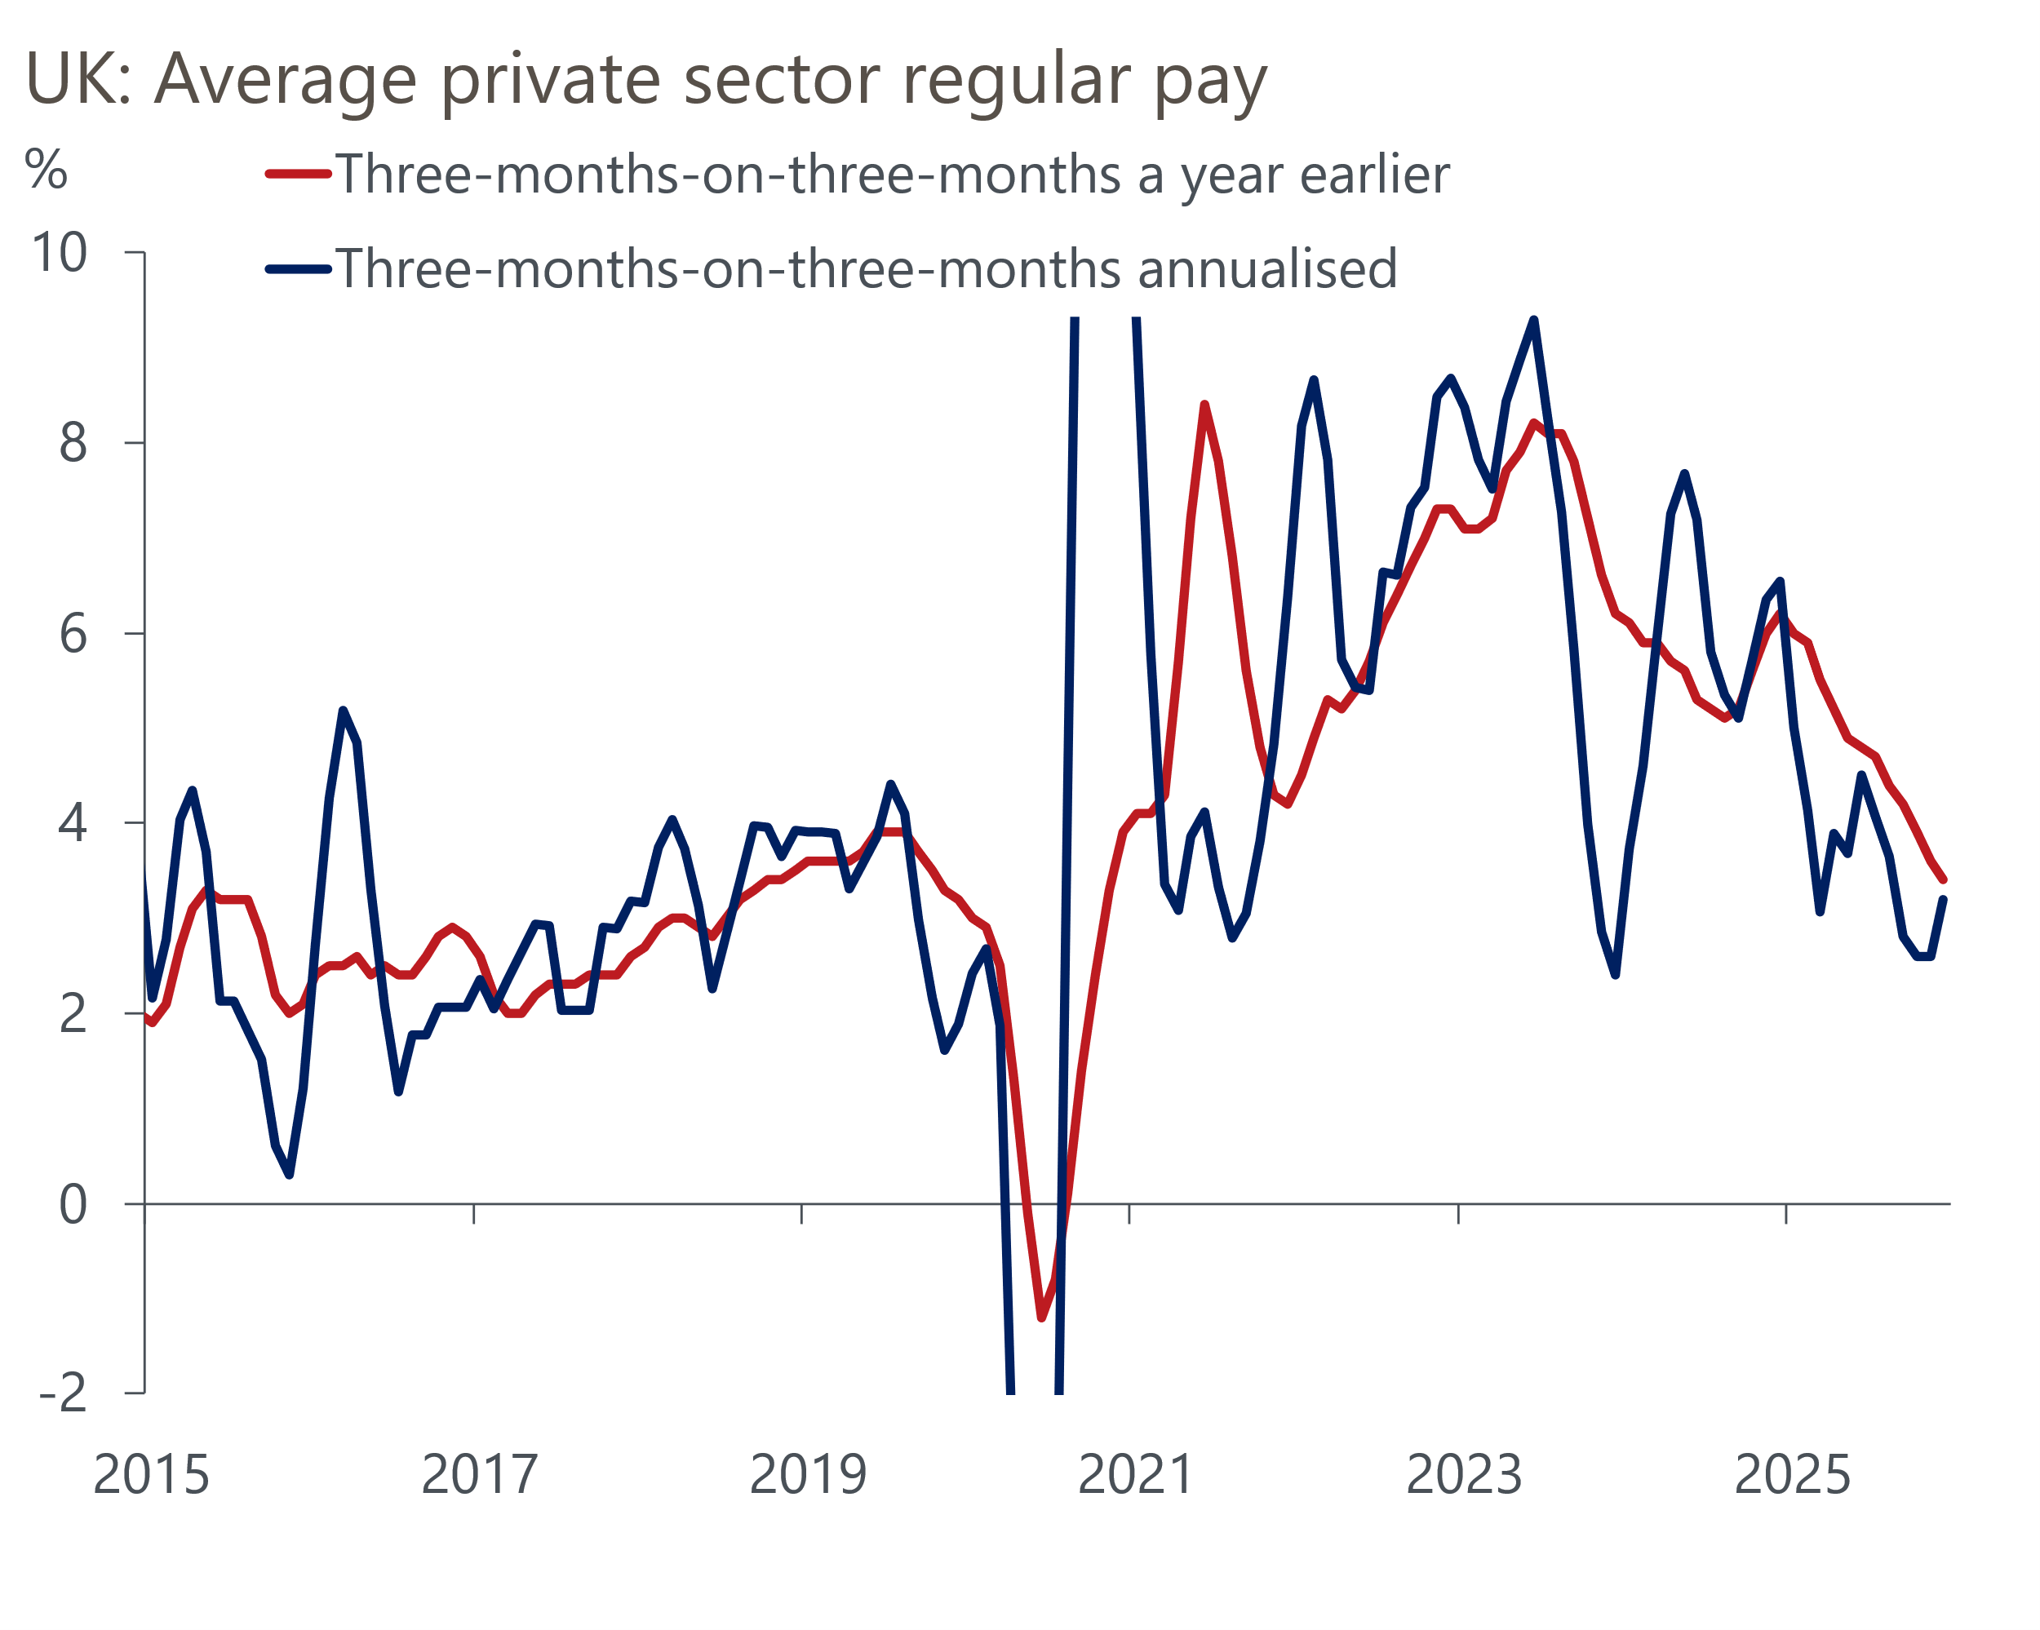
Source: Haver Analytics

It was a similar story with Wednesday's inflation release. CPI inflation dropped to 3% in January, from 3.4% in December. While markets took a signal from the chunky drop in the headline rate, the fall was primarily the result of powerful base effects and shifts in volatile components. The base effects came from a very high reading for food prices and the introduction of VAT on private school fees in January 2025. Petrol prices fell sharply between December and January, after rising over this period a year earlier. Meanwhile, there was also some payback in the notoriously erratic air fares and games and hobbies sub-categories, as December's unseasonally strong outturns unwound.
Headline inflation came in slightly above the BoE staff forecast of 2.9% in January, while services inflation overshot the BoE's projection by 0.3ppts. What's more, the MPC's favoured measure of underlying services inflation – which excludes indexed prices and some of the more volatile components – jumped by 0.2ppts in January (Chart 2).
Chart 2: Services inflation edged downwards in January, but underlying pressures jumped
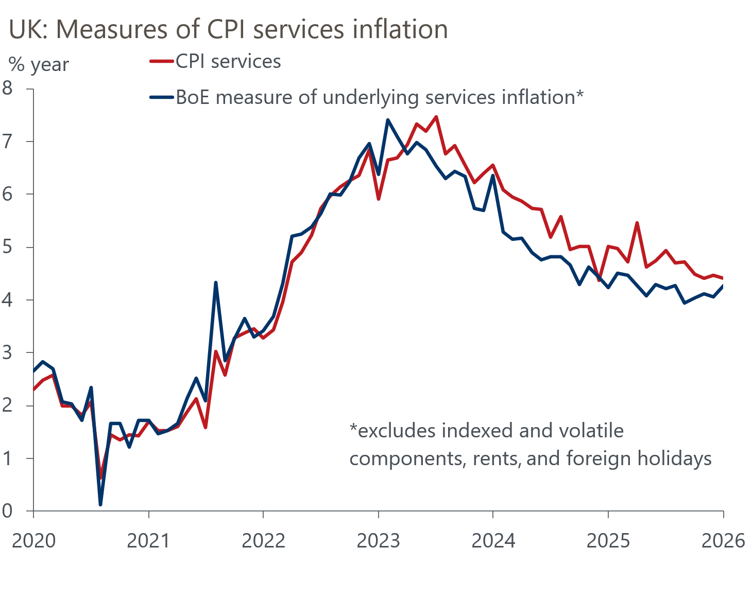
Source: Oxford Economics calculations using data from Haver Analytics
February's dovishness had been triggered by the MPC placing greater focus on the subdued growth outlook. This week's activity data was very strong, but we're sceptical this underlying picture is quite as positive and we think the MPC will also interpret the data cautiously. Retail sales volumes jumped 1.8% month-on-month in January. But much of the strength was narrowly focused, with the Office for National Statistics reporting that this was largely the result of strong auctions of items such as artwork and antiques, alongside improved sales at online jewellers.
Similarly, February's flash S&P Global survey saw the composite PMI edge up to a 22-month high of 53.9, from 53.7 in January. However, the survey's recent outturns look like outliers compared with other survey indicators, and we suspect the underlying pace of official output growth is much softer than implied by the PMIs.
Thursday's financial market pricing implied an 81% probability of a March rate cut, but we think the decision is more finely balanced. The MPC will see a further round of GDP, labour market, and inflation data before the March decision. But we should get a steer on how several committee members have interpreted recent data much sooner. BoE Governor Andrew Bailey is scheduled to appear at the House of Commons' Treasury Select Committee on Tuesday, alongside Alan Taylor, Megan Greene, and Huw Pill. Meanwhile, Taylor, Pill, and Clare Lombardelli are also to due to speak at separate public events next week.
Bailey has cast the deciding vote at four of the past five meetings. In the February minutes, Catherine Mann had suggested she was beginning to contemplate voting to cut, but her comments this week suggested the chances of this happening next month are low. So Bailey switching his February vote appears to be the only path to securing a majority for a rate cut. Next week's testimony should give us a better view of where the Governor stands.

The week ahead
There are no major economic releases due to be published next week.
Table 1: Week ahead calendar
Date | Events | Period | Measure | Unit | Previous | Forecast
Feb 27 | GfK consumer confidence | Feb | Headline | % bal | -16 | -16
Feb 27 | Nationwide house prices | Feb | m/m | % | 0.3 | 0.2
Feb 27 | Nationwide house prices | Feb | y/y | % | 0.9 | 0.7
Source: Oxford Economics

Key forecasts
Table 2: UK forecast overview
(Annual percentage changes unless specified)
 | 2023 | 2024 | 2025 | 2026 | 2027 | 2028
GDP | 0.3 | 1.1 | 1.3 | 0.9 | 1.3 | 1.4
Private consumption | -0.3 | -0.1 | 1.0 | 0.9 | 1.1 | 1.3
Fixed investment | 0.5 | 1.7 | 3.4 | 0.7 | 2.1 | 2.1
Government consumption | 2.1 | 2.9 | 1.7 | 2.0 | 1.7 | 1.4
Exports of goods and services | -2.3 | 1.4 | 1.6 | 1.0 | 1.1 | 1.3
Imports of goods and services | -1.6 | 2.7 | 4.2 | 0.2 | 1.2 | 1.4
Industrial production | -2.6 | -1.3 | 0.3 | 0.7 | 1.0 | 1.2
Consumer prices | 7.3 | 2.5 | 3.4 | 2.5 | 2.6 | 2.4
Unemployment rate (%) | 4.1 | 4.3 | 4.9 | 5.3 | 5.1 | 4.8
Current a/c balance (% of GDP) | -3.6 | -3.0 | -2.8 | -3.1 | -2.8 | -2.6
Government balance (% of GDP) | 5.2 | 5.3 | 5.0 | 3.9 | 3.3 | 2.8
Central bank policy rate (%, EOP) | 5.25 | 4.75 | 3.75 | 3.25 | 3.00 | 2.75
10yr govt. bond yield (%, EOP) | 3.54 | 4.57 | 4.47 | 4.38 | 3.90 | 3.64
Exchange rate (US$ per £, EOP) | 1.27 | 1.25 | 1.35 | 1.31 | 1.30 | 1.30
Exchange rate (euro per £, EOP) | 1.15 | 1.21 | 1.15 | 1.11 | 1.10 | 1.10
Source: Oxford Economics
Table 3: Quarterly forecasts for the UK
 | 2025 |  |  |  | 2026
 | Q1 | Q2 | Q3 | Q4 | Q1 | Q2 | Q3 | Q4
GDP (% year) | 1.8 | 1.4 | 1.2 | 1.0 | 0.7 | 0.8 | 1.0 | 1.2
CPI inflation (% year) | 2.8 | 3.5 | 3.8 | 3.4 | 3.0 | 2.2 | 2.4 | 2.5
Bank Rate (%, EOP) | 4.50 | 4.25 | 4.00 | 3.75 | 3.75 | 3.50 | 3.50 | 3.25
10yr gilt yield (%, EOP) | 4.70 | 4.48 | 4.70 | 4.47 | 4.50 | 4.48 | 4.45 | 4.38
US$ per £ (EOP) | 1.29 | 1.37 | 1.35 | 1.35 | 1.35 | 1.33 | 1.32 | 1.31
Euro per £ (EOP) | 1.20 | 1.17 | 1.15 | 1.15 | 1.15 | 1.13 | 1.12 | 1.11
Source: Oxford Economics

Latest Country Economic Forecast:
February 16, 2026

Recent publications

Data Insights
February's PMI suggests economic momentum remains strong
Bumper January for tax receipts keeps public finances on track
Retail sales volumes soared at the start of 2026
Inflation falls due to base effects and volatile categories
Labour market data consistent with a rate cut in March or April

Research Briefings
Lower immigration will hit growth and raise borrowing
Dovish hold prepares the ground for more easing
Would a change in Labour's leadership affect economic policy?
Forecasters' Mailbag – Questions from our conference
MPC preview – Rates on hold amid signs of pay stickiness

Contacts

Oxford Economics' UK team
- Andrew Goodwin - Chief UK Economist - agoodwin@oxfordeconomics.com
- Edward Allenby - Senior UK Economist - eallenby@oxfordeconomics.com

